[NextWork.org](https://community.nextwork.org/c/i-have-a-question?automatic_login=true)

# Containers on Elastic Beanstalk

# 

Prajit Venkatachalam

<https://www.linkedin.com/in/prajit-venkatachalam/>



## Introducing Today's Project!

### What is Docker?

Docker is an open-source platform that helps developers create, deploy and run applications in containers. In this project, I used Docker to create containers from container images and built my own custom container image.

### One thing I didn't expect...

One thing I did not expect in this project was the absence of options to select for the EC2 instance profile in the Elastic Beanstalk setup. I had to create an IAM role for the EC2 instance to complete the Elastic Beanstalk setup.

### This project took me...

This project took me 3 hours to complete, including understanding Docker containers and images, as well as documenting the process.



## Understanding Containers and Docker

### Containers

Containers are tools for packaging applications in a way that is easy for developers to run. They are useful because they help developers and engineers work together to share their work more efficiently.

A container image is a template with app code, dependencies, and libraries to create identical containers that work the same across environments. It ensures consistency for teams, avoiding issues like "works on my machine" and accelerates onboarding for members.

### Docker

Docker is a platform for creating and managing containers, simplifying the process of working with them. Docker Desktop is a software tool for interacting with Docker, making it easier to use and manage Docker itself.

The Docker daemon is a background process that manages containers. It takes commands from the Docker client (via terminal or Docker Desktop) and handles building, running, and distributing containers, performing tasks when Docker commands are executed.



## Running an Nginx Image

Nginx (pronounced "engine-x") is a web server used to serve web pages and handle high traffic efficiently. It can also act as a proxy server, forwarding requests to other servers, balancing the load, and managing more users smoothly.

The command I ran to start a new container was 'docker run -d -p 80:80 nginx'. Docker run starts a new container, nginx- pre-existing container, (-d)-run in the background, and -p 80:80 maps port 80 on your host machine to port 80 in the container.

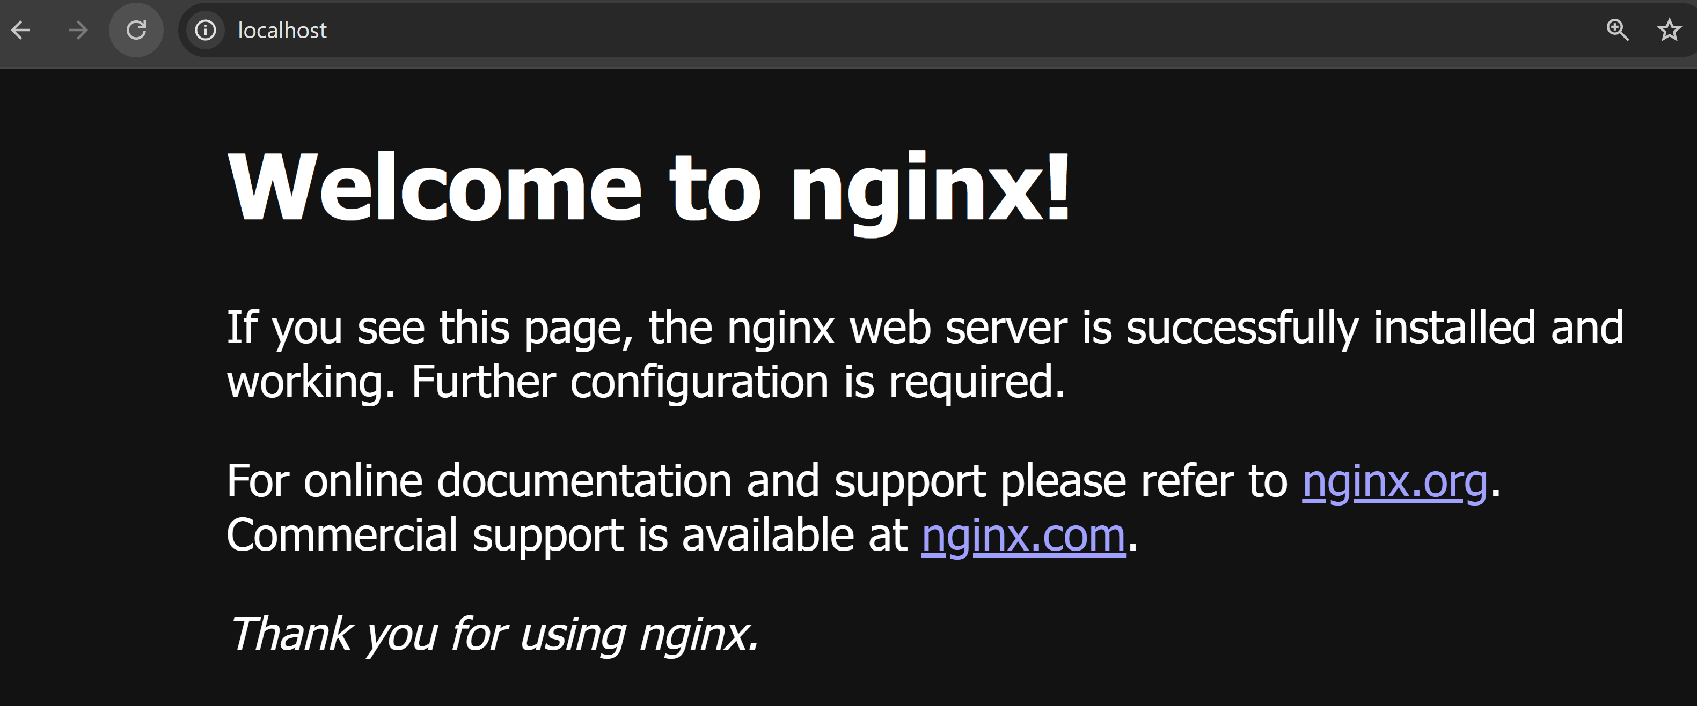



## Creating a Custom Image

The Dockerfile is a set of instructions that tells Docker how to build the custom container image.

My Dockerfile tells Docker of three things. First, it specifies that my custom container image will use the latest version of the Nginx container image as its base. Then, I will modify this base by replacing the default welcome page with my own index.html file.

The command I used to build my custom image with the Dockerfile was `docker build`. The `.` at the end of the command indicates that Docker should look for the Dockerfile in the current directory, specifically the compute folder on my desktop.

Figure 1: Docker file image

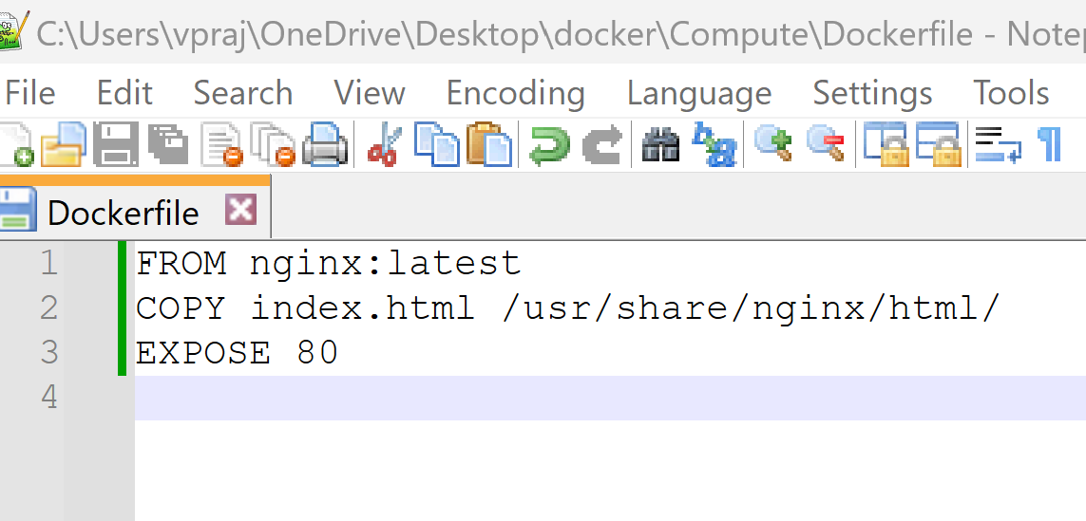



## Running My Custom Image

There was an error when I ran my custom image because I tried to map my port 80 to the new container's port 80, but that was already used by a running container. I resolved this by stopping the running container and then running the new container.

In this example, the container image serves as the template for creating a new container running on the Nginx server that serves my custom index.html file. The container is the actual software running the Nginx web server with the custom modification.

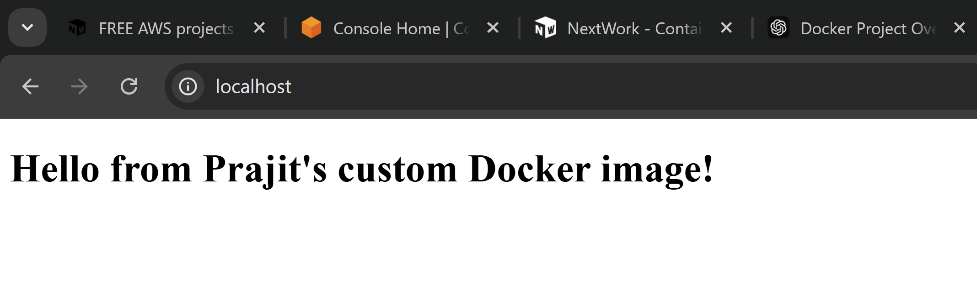



## Elastic Beanstalk

Elastic Beanstalk is an AWS service that simplifies deploying applications to the cloud. It abstracts much of the work involved in setting up cloud infrastructure, streamlining the deployment process.

Deploying my custom image with Elastic Beanstalk took me 10 minutes. This includes the time it took to launch the Elastic Beanstalk application.

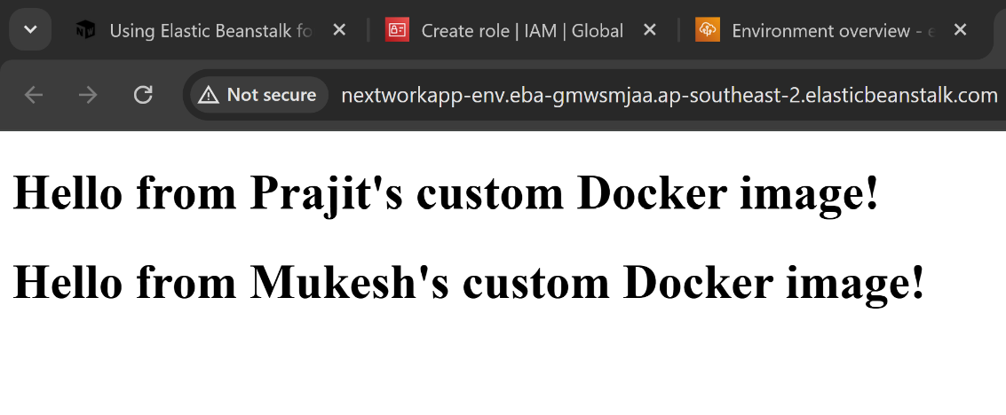

[NextWork.org](https://community.nextwork.org/c/i-have-a-question?automatic_login=true)

# Everyone should be in a job they love.

Check out [nextwork.org](https://community.nextwork.org/c/i-have-a-question?automatic_login=true) for more projects

